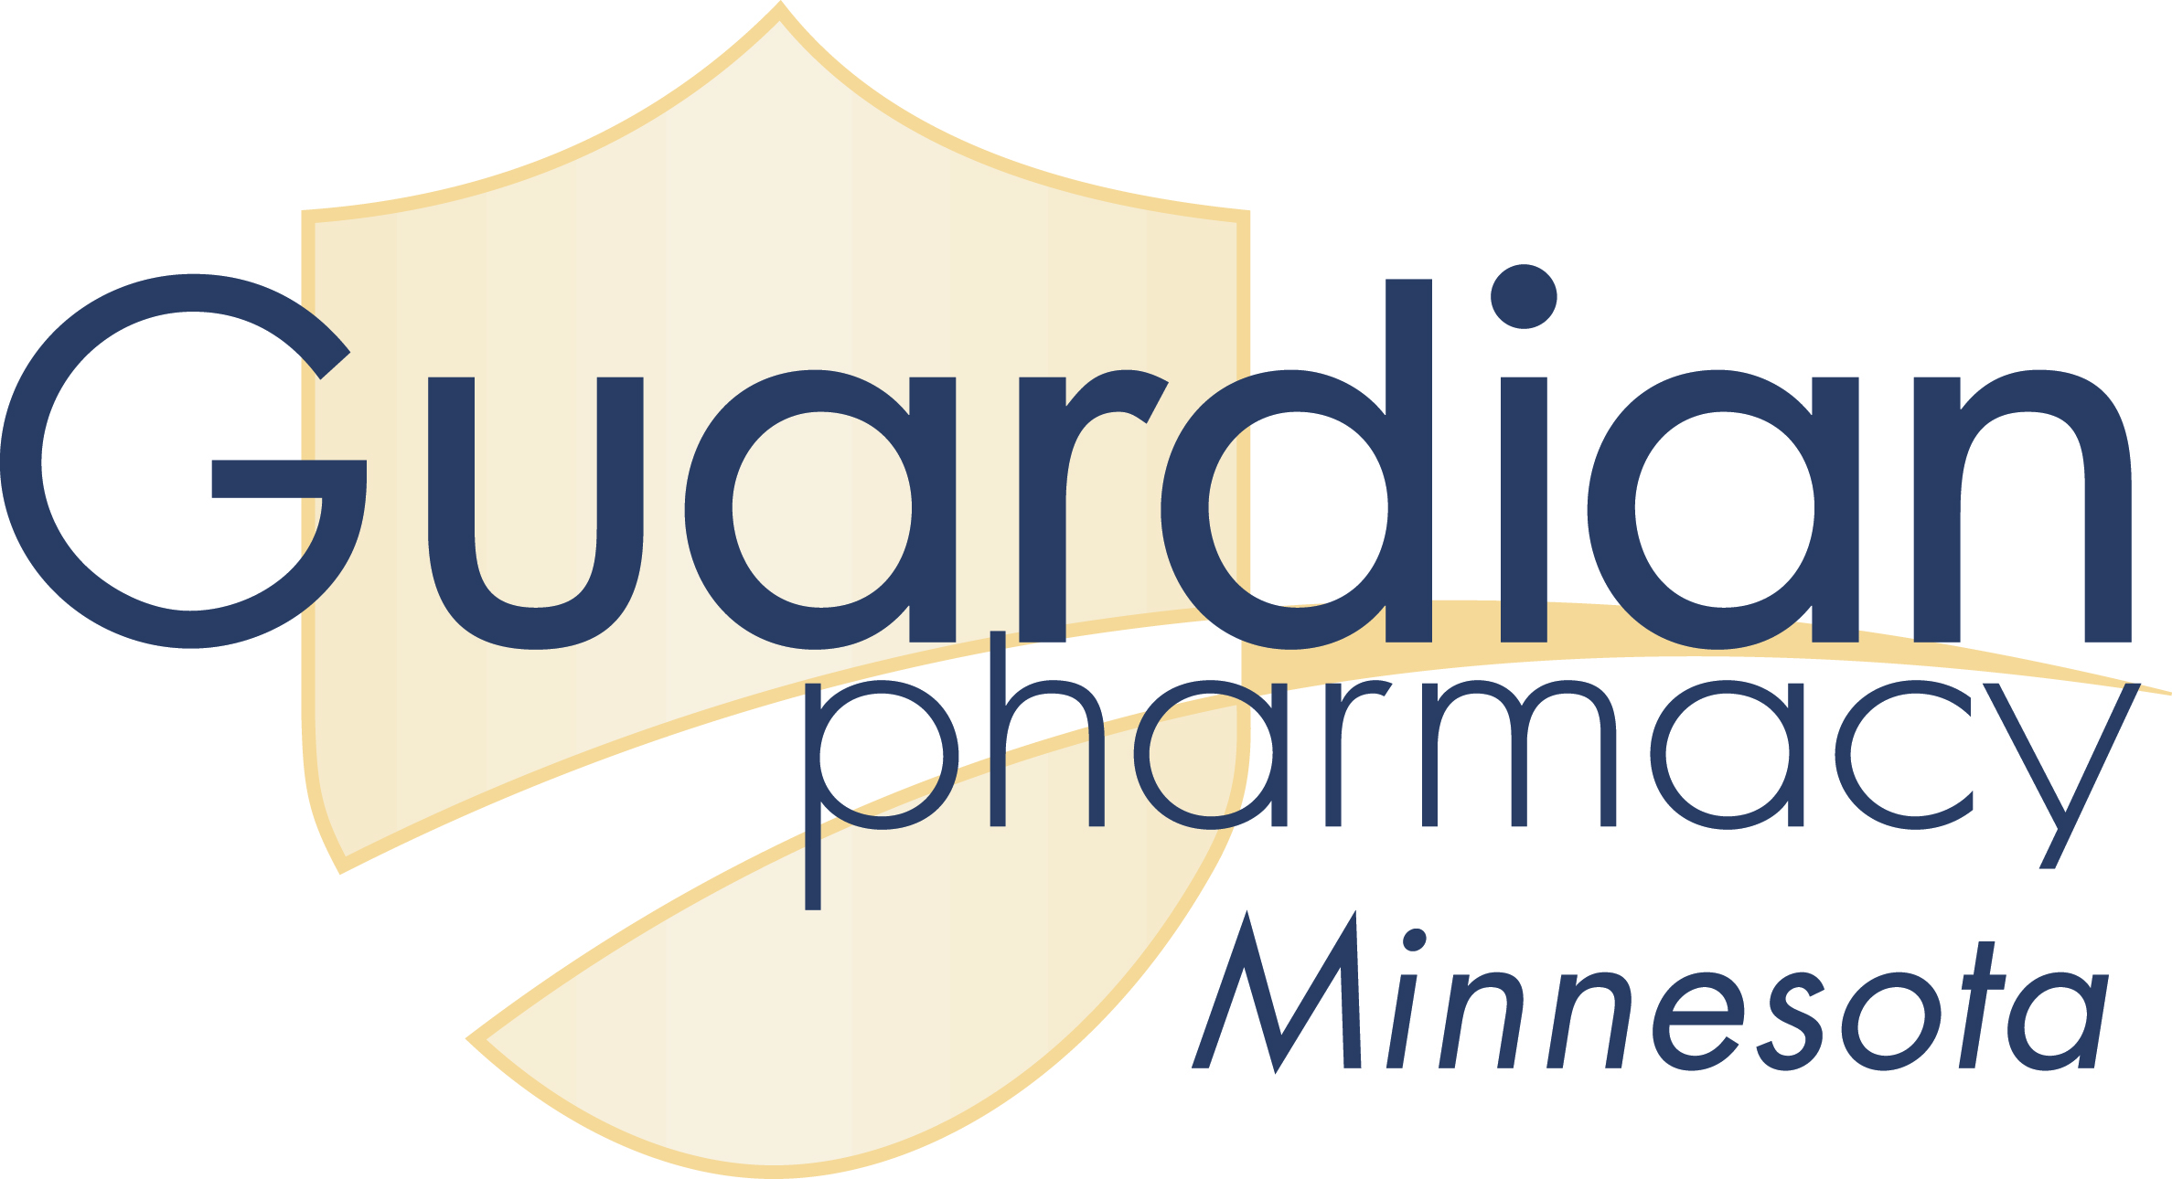
3601 18th St S - Suite 101 - St. Cloud, MN 56301
Phone: 320-230-1050 - Fax: 320-230-1051

Medication Incident Report

Date: _______________________ Nurse Discovering Incident: _____________________________
Nurse Responsible for Incident: __________________________ Signature:________________________
Patient Involved: ______________________________________ Date & Time of Incident: ___________
Attending Physician: ___________________________________ Room Number: ___________________
Medication: ____________________________________ How Ordered: __________________________

Wrong Drug: _______ Wrong Dose: _______ Wrong Time: _______ Posting Error: _______

How did incident happen: _________________________________________________
_____________________________________________________________________________________

What was the result: ____________________________________________________________________
_____________________________________________________________________________________

How could it have been prevented: ________________________________________________________
____________________________________________________________________________________

What action was taken when incident was discovered: _________________________________________
_____________________________________________________________________________________

Was Physician notified? YES - NO Dr.’s Comments: ______________________________________
_____________________________________________________________________________________

Signatures of others involved in incident: ___________________________________________________
_____________________________________________________________________________________

AN ENTRY MUST BE MADE IN THE PATIENT’S MEDICAL RECORD CONCERING THE INCIDENT

______________________________________ _____ __________________________
Nurse/Manager Executive Director

